Leaders, welcome to Sparkhouse Online!

Sparkhouse Online makes it easy for you to access your leader material anytime, anywhere. Follow the steps below to get started.

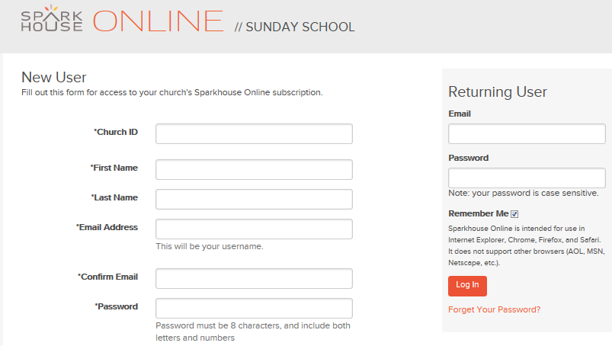
Request account access and log in
- Go to Sparkhouse Online, http://sundayschool.sparkhouseonline.org.
- Under “New User,” enter your Church ID: FPCG300
- Complete the rest of the requested information and click “Submit.”
- You will receive a confirmation e-mail
welcoming you to Sparkhouse Online once
the account administrator approves your request.
- Return to Sparkhouse Online.
- Enter your e-mail address and password under “Returning User.” Click “Log In.”

Edit your profile information
- Click on your name in the upper right corner of the Home page.
- On the form that displays next, update your profile information, change your password, and add Family Members as needed. Click “Save” when you are done.

Download leader material starting from the Home page
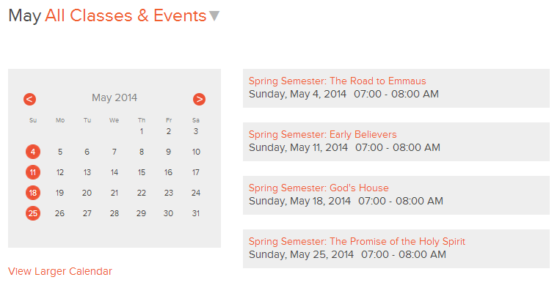
- After the director assigns you as the leader of a group of students, your upcoming assignments will display in the “Assigned Classes & Events” section of the Home page. To display this list, click on the arrow or the orange text above the calendar. Use the left and right arrows in the calendar to go to another month.
- Click on the name of a Class or Event.
- Your resources will be listed on the next page. Select the files you want and download.

Download leader material from the Sparkhouse Online Library
You can access and download leader material, search, and more in the Library.
- Go to the Library tab.

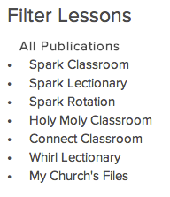
- In the Filter Lessons Panel, click on the curriculum, unit or quarter, lesson title, and age level you will be leading or teaching. (Note: For those using the rotation model, the layers are a bit different.)

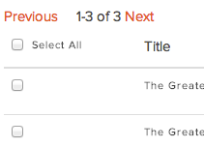
- In the list of your search results, check the box next to each file you want to download, or check the box next to “Select All.”

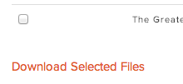
- Click “Download Selected Files” to have all of your selected files download together in a .zip folder.

Upload your own files to the Sparkhouse Online Library
Have a useful resource of your own? Add it to “My Church’s Files.” NOTE: these files are visible and available only to others on your church’s Sparkhouse Online account.
- Go to the Library tab.
- Click “Upload New Resource.”
- Browse to find the file(s) you wish to upload.
- Enter a Title and (optional) Keywords for your resource.
- Click “Save.”

Other Library Tips and Tricks
Search Results: Any time you conduct a search or apply a filter in the library, your results will be organized by lesson title or Bible story in scope and sequence order. For churches that subscribe to more than one curriculum, results are organized by curriculum and then by scope and sequence.

Advanced Options: The Advanced Options panel, located below the “Search” button, makes it easy to filter by specific kinds of resources. And we’ve added more advanced options to make it even easier to find lesson resources. Click here to open and close this panel.
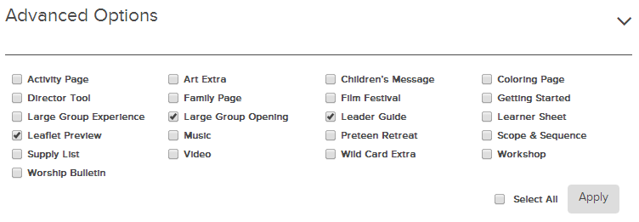

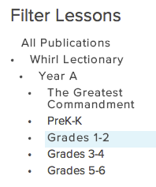
Filter Lessons Panel: Use the Filter Lessons Panel to find materials or resources for a particular unit, quarter, or story. You can even drill down to specific age levels or workshops!

Send a message
- Go to the “Message Center” tab to send a message to the director, other leaders, or parents who are using your church’s Sparkhouse Online subscription.

